**上海德大天壹化工设备有限公司**

清洗说明

概述Summary

本说明适用于型号为BM-5(10)/BML-5(10)/DZL-5(10)-G等型号的刮板薄膜蒸发器及短程蒸馏器的清洗工作。

This description is suitable for cleaning scraper film evaporator and short-range distillator of BM-5(10)/BML-5(10)/DZL-5(10)-G type.

**一、安全注意事项**

**I．Safety precautions**

1、玻璃部件请勿敲打、碰撞。

1. Do not knock or collide glass parts.

2、连接口处请装好密封O型圈或涂抹真空硅脂。

2. Seal O-ring or vacuum silicone grease should be installed at the joint.

3、拆卸、装配时轻拿轻放，拆卸前请务必做好主要部位粘贴标签及拍照留底的工作。

3. When disassembling and assembling, take it lightly and handle it lightly. Before disassembling, please do a good job of sticking labels on the main parts and taking photos to keep the bottom.

4、电控柜通电后请勿用手触摸柜内裸露元气件，以防触电！

4. Don't touch the bare elements in the cabinet with your hands after the electric cabinet is powered on, in order to prevent electric shock!

5、高温使用状态中，请勿用手触摸裸露部分，以免烫伤。

5. Do not touch the exposed part with your hands in high temperature condition to avoid scalding.

**二、清洗前准备工作**

**II．Preparations before cleaning**

1、确定清洗类型

1. Determine the cleaning type

清洗分为日常清洗、灌装清洗、大清洗。日常清洗主要为当日实验（生产）完成后，为避免设备中残留的物料将转子与蒸发器桶壁粘结，避免造成下次使用时损坏，此情况需要进行日常清洗。灌装清洗主要是上批实验（生产）的物料完工后，下批需要更换另外的物料，为避免交叉污染，需要对设备里面进行全覆盖、无死角地清洗。大清洗指的是设备正常使用2年以上，或主要密封件部位损坏，或转子损坏，需要更换主要密封件并且转子部件、桶体内壁需要刷洗，此情况需要进行大清洗。

Cleaning is divided into daily cleaning, filling cleaning and large cleaning. Daily cleaning is mainly for the day after the experiment (production), in order to avoid the residual material in the equipment will be the rotor and evaporator barrel wall bonding, to avoid damage in the next use, this situation requires daily cleaning. Filling and cleaning is mainly after the material of the previous batch of experiments (production) is completed, the next batch needs to replace other materials, in order to avoid cross-contamination, the equipment needs to be fully covered and cleaned without dead corners. Large cleaning refers to the equipment used normally for more than 2 years, or the main sealing parts are damaged, or the rotor is damaged, the main sealing parts need to be replaced, and the rotor parts, barrel inner walls need to be scrubbed, this situation requires large cleaning.

2、确定清洗溶剂及用量

2. Determine the cleaning solvent and dosage

根据物料的溶解性选择合适的清洗溶剂。通常情况下可用水、乙醇等（下文为为乙醇清洗说明）。

Choose the appropriate cleaning solvent according to the solubility of the material. Usually water, ethanol and so on are available (the following is the ethanol cleaning instructions).

3、确定清洗步骤

3. Determine cleaning steps

溶剂选择好了后，估算清洗温度、流量、压力等。通常情况下在常压下清洗。

After the solvent is selected, the cleaning temperature, flow rate and pressure are estimated. Usually it is cleaned under normal pressure.

**三、清洗工作**

**III．Cleaning**

1、日常清洗

1. Daily cleaning

1.1清洗前准备

1.1 Pre-cleaning preparation

1.1.1清洗溶剂：95%（V%）乙醇，用量2L

1.1.1 Washing Solvent: 95% (V%) Ethanol, 2L

1.1.2清洗温度：120℃（夹套导热油温度），50℃（预热夹套温度），-5℃～10℃(冷却水温度)

1.1.2 Cleaning Temperature: 120 C (Jacket Heat Conducting Oil Temperature), 50 C (Preheating Jacket Temperature), - 5 C~10 C (Cooling Water Temperature)

1.1.3清洗流量：进料泵转速从20RPM慢慢调整到50RPM，稳定在50RPM。

1.1.3 Cleaning Flow: Feed pump speed slowly adjusted from 20 RPM to 50 RPM, stable at 50 RPM.

1.1.4清洗压力：常压

1.1.4 Cleaning Pressure: Atmospheric Pressure

1.2清洗步骤及方法

1.2 Cleaning steps and methods

1.2.1取2L乙醇加入到高位进料器中（乙醇可分批加入到高位进料器里）。

1.2.1 Take 2L ethanol and add it to the high feeder (ethanol can be added to the high feeder in batches).

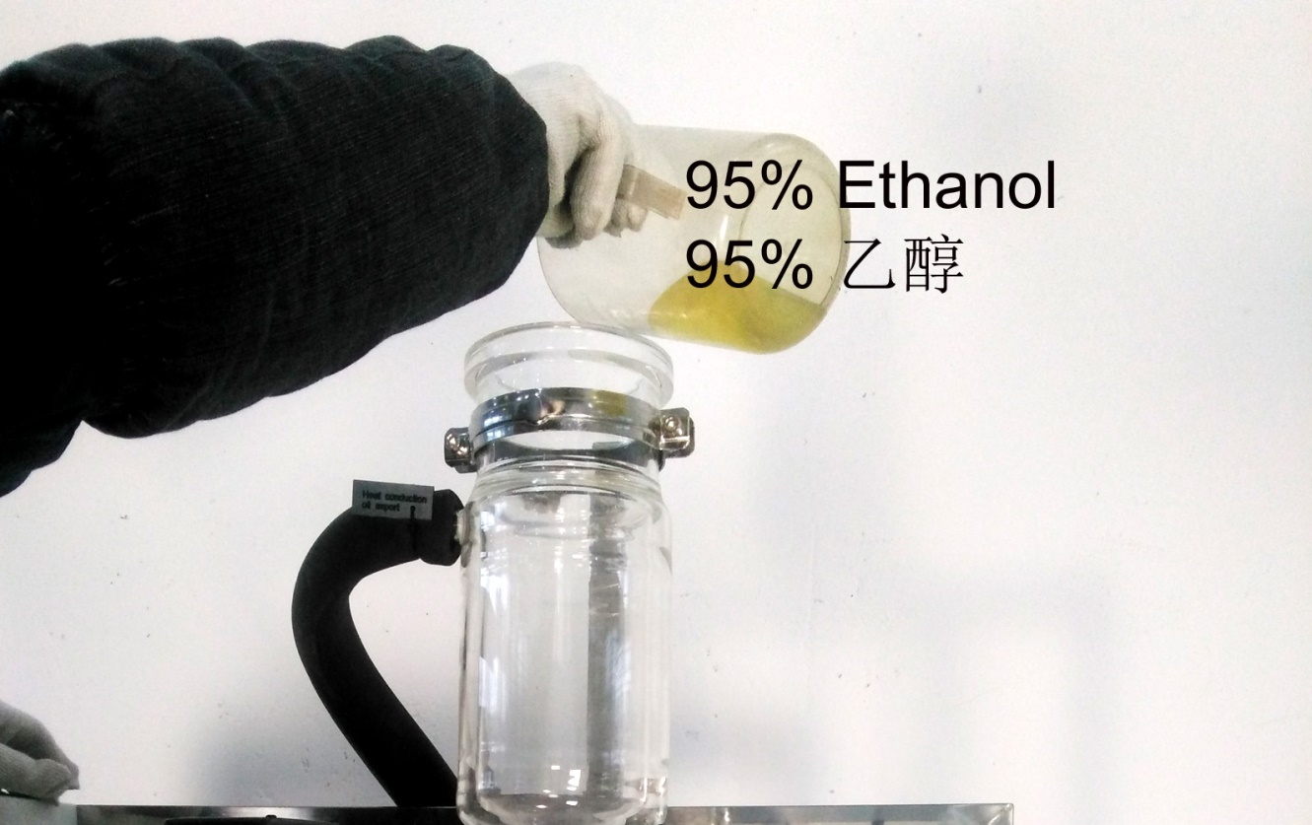

1.2.2开加热器电源开关，打开预热恒温槽的循环开关，预热温度到设定50℃左右，夹套加热温度设定到120℃左右。

1.2.2 Open the heater power switch, open the cycle switch of the preheating constant temperature tank, the preheating temperature is set to about 50 ℃, and the jacket heating temperature is set to about 120 ℃.

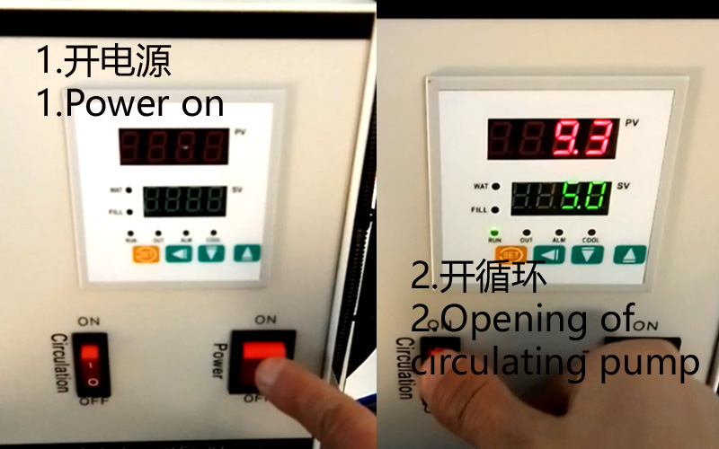

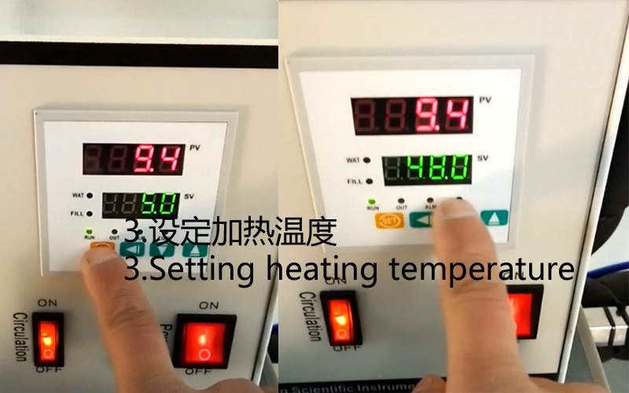

1.2.3拆开真空管道，让系统保持在常压状态。

1.2.3 Remove the vacuum pipe to keep the system at atmospheric pressure.

以下图片为刮板器The following picture is the scraper

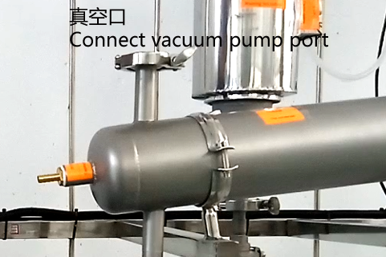

以下图片为短程蒸馏器

The following picture shows a short-range distiller

注意：短程蒸馏器的真空口装一个朝上的口，口的位置高度需要达到进料口的位置。

Note: The vacuum port of the short-range distiller is equipped with an upward orifice. The height of the orifice needs to reach the position of the inlet and outlet.

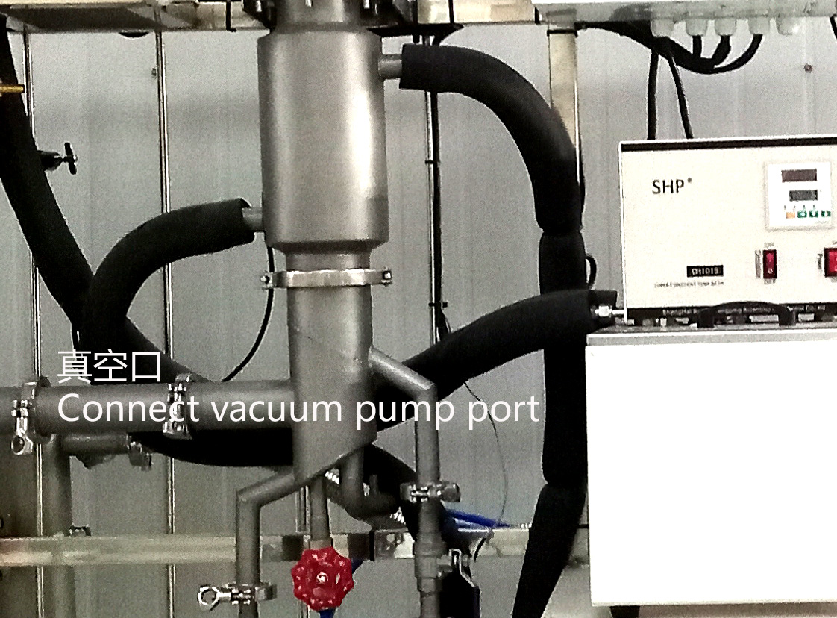

1.2.4冷凝器中通入冷却水，冷却水的温度为-5℃～10℃。

1.2.4 The cooling water is introduced into the condenser, and the temperature of the cooling water is - 5 ℃to 10 ℃.

1.2.5打开进料阀和进料泵，设定进料转速为20RPM。

1.2.5 Open the feed valve and the feed pump, and set the feed speed to 20RPM.

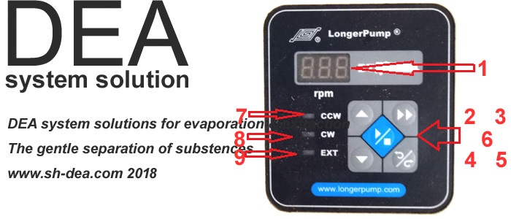

1-泵转速显显示屏；2-泵转速增加；3-泵全速运行；4-泵转速减少；5-正反转按键；6-停止启动按键；7-正转指示灯；8-反转指示灯；9-停止状态指示灯

1- pump speed display screen; 2- increase of pump speed; 3- pump running at full speed; 4- reduced pump speed; 5- forward and reverse button; 6- stop the start button; 7- forward turn indicator light; 8- reverse indicator light; 9- stop status indicator light

1.2.6打开搅拌电机，并设定搅拌转速为150RPM。

1.2.6 Turn on the stirring motor and set the stirring speed to 150 RPM.

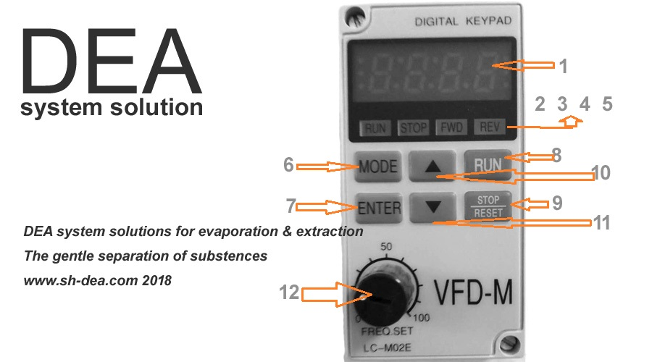

1-转速、参数显示框；2-运行指示灯；3-停止指示灯；4-正转指示灯；5-反转指示灯；6-参数变换键；7-确定（ENTER）键；8-启动运行按键（RUN）；9-停止运行按键（STOP）；10-上翻按键（改变参数时使用）；11-下翻按键（改变参数时使用）

1- speed, parameter display box; 2- running indicator light; 3- stop indicator light; 4- forward turn indicator light; 5- reverse indicator light; 6- parameter transformation key; 7- determine (ENTER) key; 8- start the operation button (RUN); 9- STOP button; 10- upturn button (used when changing parameters); 11- flip down button (when changing parameters)

1.2.7打开接收阀，接收轻重相流出物。待重相接收到1000ml左右，可将重相重新倒入至高位进料器中，再次利用。

1.2.7 Open the receiving valve to receive light and heavy phase effluents. When the heavy phase is received to about 1000ml, the heavy phase can be re-poured into the high-level feeder and reused.

1.2.8保持此状态，持续运行30分钟以上。此后慢慢将进料转速调整到50RPM，并持续运行30分钟以上。

1.2.8 to maintain this state, running for more than 30 minutes. After that, the feed speed was slowly adjusted to 50RPM and kept running for more than 30 minutes.

**注：清洗的时间以重相接收的乙醇干净无变色为准。如重相接收的乙醇颜色为黑色，说明清洗时间不够，或清洗溶剂不对。**

**Note: The cleaning time shall be based on the clean and non-discoloration of ethanol received in the heavy phase. If the color of ethanol received by the heavy phase is black, the cleaning time is not enough or the cleaning solvent is not right.**

1.2.9取出轻重相物料，装在储罐里，下次使用。并关闭加热。

1.2.9 Remove light and heavy phase materials and put them in storage tanks for next use. And turn off the heating.

1.2.10将真空口接上水环真空泵，将系统内残留乙醇抽走，并保持系统内干净、干燥，预留下次使用。

1.2.10 Connect the vacuum port to the water ring vacuum pump, remove the residual ethanol in the system, keep the system clean and dry, and reserve for next use.

2、灌装清洗

2. Filling and cleaning

2.1清洗前准备

2.1 Pre-cleaning preparation

2.1.1清洗溶剂：95%（V%）乙醇，用量10L。

2.1.1 Washing solvent: 95% (V%) ethanol, dosage 10L.

2.1.2清洗温度：50℃（夹套导热油温度）。

2.1.2 Cleaning temperature: 50℃ (temperature of heat conducting oil in jacket).

2.1.3清洗压力：常压

2.1.3 Cleaning Pressure: Atmospheric Pressure

2.2清洗步骤及方法

2.2 Cleaning steps and methods

2.2.1将系统进行日常清洗，清洗步骤见上。

2.2.1 Daily cleaning of the system. See above for cleaning steps.

2.2.2拆开真空管道，让系统保持在常压状态。

2.2.2 Remove the vacuum pipe to keep the system at atmospheric pressure.

2.2.3关上轻相、重相接收阀。

2.2.3 Close the light and heavy phase receiving valves.

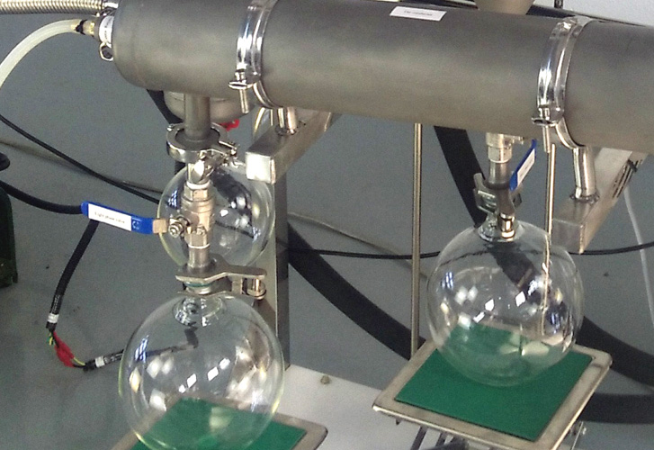

2.3.4打开进料泵，将进料转速调至最大，将乙醇泵入止蒸发器系统中。

2.3.4 Open the feed pump, adjust the feed speed to the maximum, and pump the ethanol into the anti-evaporator system.

**注意：泵入过程中，真空口出料时加入的乙醇量正好合适。**

**Note: During the pumping process, the amount of ethanol added during**

**the discharge of the vacuum outlet is just right.**

2.3.5打开夹套加热的恒温槽，保持夹套导热油温度为50℃

2.3.5 Open the thermostat of jacket heating and keep the temperature of heat conducting oil of jacket at 50 ℃

2.3.6 Turn on the stirring motor and set the stirring speed to 50 RPM.

2.3.7保持此状态，持续运行2小时以上。

2.3.7 to maintain this state, continuous operation for more than 2 hours.

2.3.8排出乙醇，将真空口接上水环真空泵，将系统内残留乙醇抽走，并保持系统内干净、干燥，预留下次使用。

2.3.8 Ethanol is discharged, the vacuum port is connected with the water ring vacuum pump, the residual ethanol in the system is removed, and the system is kept clean and dry, and reserved for next use.

3、大清洗

3. Big cleaning

3.1清洗前准备

3.1 Pre-cleaning preparation

3.1.1设备清理干净，拆下接收瓶。

3.1.1 Clean up the equipment and remove the receiving bottle.

3.1.2准备干净的抹布、乙醇、密封油、试剂瓶刷子、钢丝刷等

3.1.2 Prepare clean rags, ethanol, sealing oil, reagent bottle brushes, wire brushes, etc.

3.1.3外六角开口扳手（8#、10#、13#、14#、17#、19#、活动扳手）各2把，内六角扳手1套，十字螺丝刀、一字螺丝刀各1把，橡胶锤头1把，游标卡尺1把。

3.1.3 Two outer hexagonal open wrenches (8, 10, 13, 14, 17, 19, movable wrenches), one inner hexagonal wrench, one cross screwdriver, one word screwdriver, one rubber hammer and one vernier caliper.

3.2清洗步骤

3.2 Cleaning steps

3.2.1依次拆开汽相出口管道、松开联轴器、松开电机拆卸螺栓、取下电机及电机座、松开主机螺栓取出传动及密封。

3.2.1 In turn, the steam outlet pipe is dismantled, the coupling is loosened, the motor bolt is dismantled, the motor and the motor seat are removed, and the main engine bolt is loosened to remove the transmission and seal.

3.2.2取出刮片，并将四氟刮片放入至溶剂中浸泡。取出刮轮装置，同时浸泡在溶剂中。浸泡时间约为3～5小时。

3.2.2 Remove the scraper and soak it in solvent. Remove the scraper device and soak it in the solvent at the same time. The soaking time is about 3-5 hours.

以下图片为刮板器

The following picture is the scraper

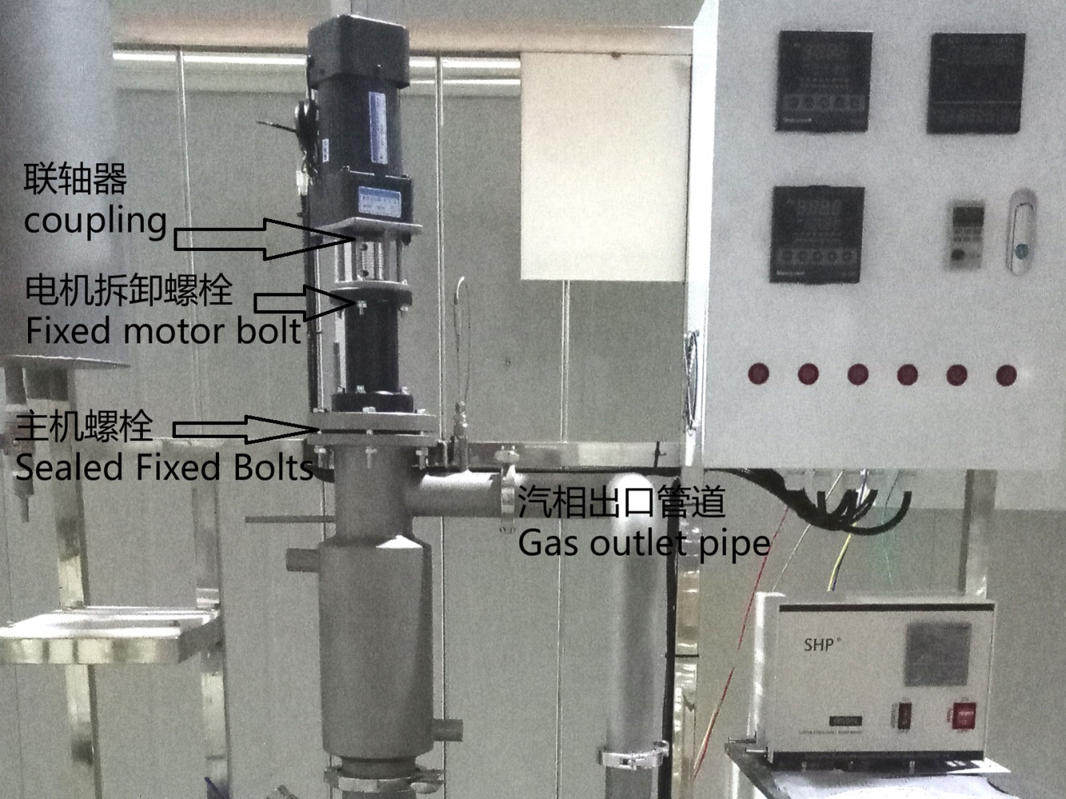

以下图片为短程蒸馏器

The following picture shows a short-range distiller

注意：下冷凝器法兰也需要松开，中心冷凝器需要取出。

Note: The lower condenser flange also needs to be loosened, and the central condenser needs to be removed.

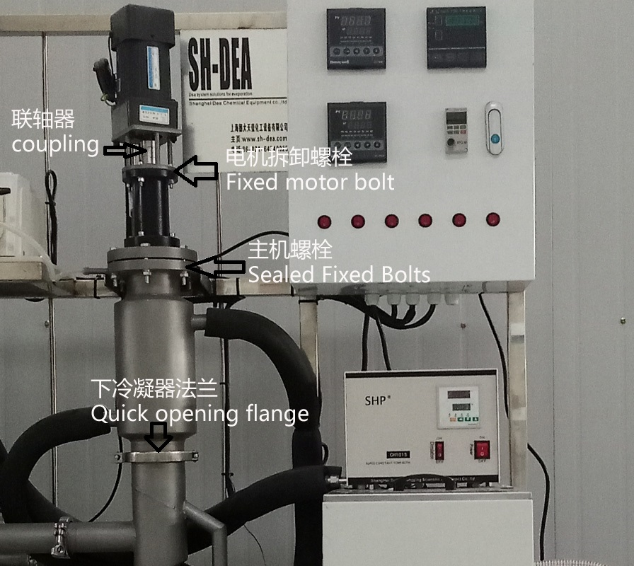

3.2.3拆下传动密封部件，更换骨架油封。

3.2.3 Remove the transmission seal components and replace the skeleton oil seal.

3.2.4清洗完毕，安装相反顺序装配起来。

3.2.4 After cleaning, install and assemble in reverse order.

3.2.5装配完毕，按照日常清洗步骤，清洗一遍，晾干待用。

3.2.5 After assembly, according to the routine cleaning steps, clean once, dry and stand by.